**Exercise 1: Setting Up Junit**

**App.java**

package org.example1;  
  
*/**  
 * A simple application that provides an addition method.  
 */*public class App {  
  
 public static void main(String[] args) {  
 App app = new App();  
  
 int a = 10;  
 int b = 20;  
 int result = app.add(a, b);  
  
 System.*out*.println("Sum of " + a + " and " + b + " is: " + result);  
 }  
  
 // Method to add two integers  
 public int add(int a, int b) {  
 return a + b;  
 }  
}

**AppTest.java :**

package org.example1;  
  
import org.junit.Test;  
import static org.junit.Assert.*;  
  
*/**  
 * Unit tests for App class.  
 */*public class AppTest {  
  
 @Test  
 public void testAdd_PositiveNumbers() {  
 App app = new App();  
 int result = app.add(5, 3);  
 System.*out*.println("Test Positive Numbers: 5 + 3 = " + result);  
 *assertEquals*(8, result);  
 }  
  
 @Test  
 public void testAdd_NegativeNumbers() {  
 App app = new App();  
 int result = app.add(-5, -3);  
 System.*out*.println("Test Negative Numbers: -5 + (-3) = " + result);  
 *assertEquals*(-8, result);  
 }  
  
 @Test  
 public void testAdd_MixedNumbers() {  
 App app = new App();  
 int result = app.add(5, -3);  
 System.*out*.println("Test Mixed Numbers: 5 + (-3) = " + result);  
 *assertEquals*(2, result);  
 }  
}

**pom.xml :-**

<project xmlns="http://maven.apache.org/POM/4.0.0" xmlns:xsi="http://www.w3.org/2001/XMLSchema-instance"  
 xsi:schemaLocation="http://maven.apache.org/POM/4.0.0 http://maven.apache.org/xsd/maven-4.0.0.xsd">  
 <modelVersion>4.0.0</modelVersion>  
  
 <groupId>org.example1</groupId>  
 <artifactId>Exerceise3</artifactId>  
 <version>1.0-SNAPSHOT</version>  
 <packaging>jar</packaging>  
  
 <name>BankingApp</name>  
 <url>http://maven.apache.org</url>  
  
 <properties>  
 <project.build.sourceEncoding>UTF-8</project.build.sourceEncoding>  
 </properties>  
  
 <dependencies>  
 <dependency>  
 <groupId>junit</groupId>  
 <artifactId>junit</artifactId>  
 <version>3.8.1</version>  
 <scope>test</scope>  
 </dependency>  
  
  
  
 <dependency>  
 <groupId>junit</groupId>  
 <artifactId>junit</artifactId>  
 <version>4.13.2</version>  
 <scope>test</scope>  
 </dependency>  
 <dependency>  
 <groupId>junit</groupId>  
 <artifactId>junit</artifactId>  
 <version>RELEASE</version>  
 <scope>compile</scope>  
 </dependency>  
  
 </dependencies>  
</project>

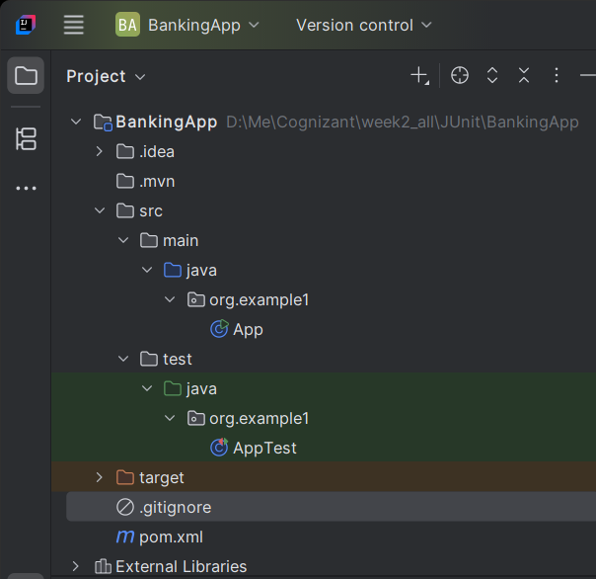

**Output :-**

